**HW3 MATLAB code**

1.

function h = hr(t, hn, N1, N2, T)

h = zeros(size(t));

n = N1:N2;

f = @(x) sum(hn.*sin(pi*(x-n*T)/T)./(pi*(x-n*T)/T));

for i = 1:length(t)

h(i) = f(t(i));

end

2.

N1 = -6;

N2 = 6;

T = 1/6;

n = N1:N2;

td = n/6;

t = -1:0.001:1;

h = @(t) cos(2*pi*t);

hn = h(td);

hr = hr(t,hn,N1,N2,T);

plot(t,h(t));

hold on

plot(td,h(td),'o');

hold on

plot(t,hr,'--');

title('h(t)=cos(2\pit)');

xlabel('t'); ylabel('h(t)');

legend('Original curve', 'Data points', 'Reconstructed curve')

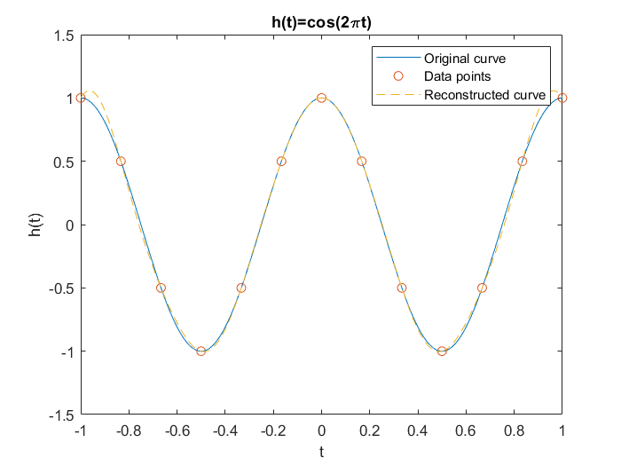

The constructed curve does not completely match the original curve, because the data values which between sampled data points h[n] are determined by interpolation of sinc function. If the number of h[n] goes larger, then the reconstructed curve will get closer to the original curve.

3.

N1 = -9;

N2 = 8;

T = 1/1.5;

n = N1:N2;

td = n/1.5;

t = -3:0.001:3;

h = @(t) cos(2*pi*t);

hn = h(td);

hr = hr(t,hn,N1,N2,T);

plot(t,h(t));

hold on

plot(t,hr,'--');

title('h(t)=cos(2\pit)');

xlabel('t'); ylabel('h(t)');

legend('Original curve', 'Reconstructed curve');

The sampling interval *Ts* is

$$T_{s}=\frac{1}{1.5}=\frac{2}{3} (s)$$

The sampling frequency *fs* is the reciprocal of sampling interval *Ts*.

But the critical frequency of function h(t) is

$$f_{c}=1 (Hz)$$

Since *fs* < 2*fc*, aliasing happens.